Click
First
^{aFirst}
^{bSecond}
Abstract
Abstract contents should not exceed 250 words. You may add graphical abstract, tables and references, but the total content should NOT exceed ONE page.

Font size: Times New Roman -11 points, 1.5 line spacing

Keywords: Type your keywords here, separated by semicolons [maximum of 6];

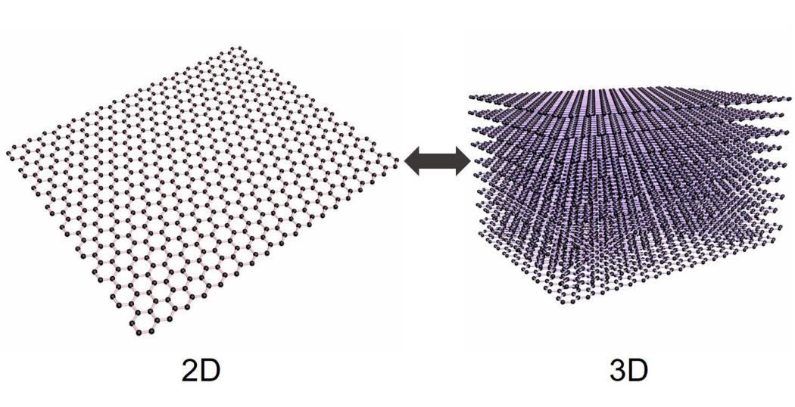

Fig.1: 2D and 3D structure of Graphene

Reference Format:

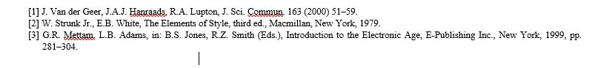

*End Page*

